Youchun Zhang

Thesis Studio 1

6 November 2018

Milestone Paper – Prototype

This thesis prototype is experimenting with the forms to answer the questions raised in the research phase, including how the algorithmic transparency is affecting the daily experience of its users and employees and what are the current academic and legal reactions addressing this problem. It chooses YouTube, one of the biggest video-sharing websites in the world as the main researching platform and focuses on one specific algorithm-controlled system: the recommendation system.

*Impact and Coverage of YouTube*

YouTube is the biggest online video platform featuring a wide variety of user-generated contents. It was purchased by Google in 2006. Originally, YouTube is being used so that user can post original content that is either funny or worth being shared for many other reasons. In 2016, the number of YouTube users has reached 1.35 billion. According to the forecast, this number will climb to 1.86 billion in 2021.

Currently, the category of contents being generated by users has been extended to video blogs, gaming videos, instructional videos, and educational videos. As of July 2015, more than 400 hours of video were uploaded to YouTube every minute. As of September 2018, the number of subscribers of the most popular YouTube channels has reached over 65 million.

YouTube can also be accessed as part of its partnership program. 81 percent of global internet users have visited YouTube in the recent month, and 31 percent of YouTube users access it more than once per day.

YouTube uses Google AdSense, a program closely works with Ad-tech and helps the publisher make money from their online content. In 2017, Google's share of total U.S. digital advertising revenues amounted to 38.6 percent, as compared with 19.9 percent share to Facebook. Some of the top paying AdSense niches are Finance, Internet Marketing, Technology, Web Hosting, Internet & Computers.

*Prototypes: Experiments*

Three prototypes are created in the prototyping experiments. The first prototype is about creating a workflow that asks the audience to actively request for the disclosure of the mechanics within an algorithm-controlled system. The hardware part is mainly consist of a button, a mini-size thermal printer, the Arduino Uno, and some wires. The Arduino Uno has been pre-programmed through its IDE specifying a message sent from "Algorithm Service Department". Once the audience presses the button, a piece of paper will be printed out from the thermal printer stating the process and the goal of YouTube algorithms. The audience can keep the paper as a personal copy of the record.

The message is based on a reverse engineering article for the YouTube video publishers. The conclusions drew by the author of this article are, YouTube uses user's Watch History, Search HIstory, and Demographic Information, and the goal of the YouTube's promotional algorithm is to promote videos to lead to longer viewer sessions.

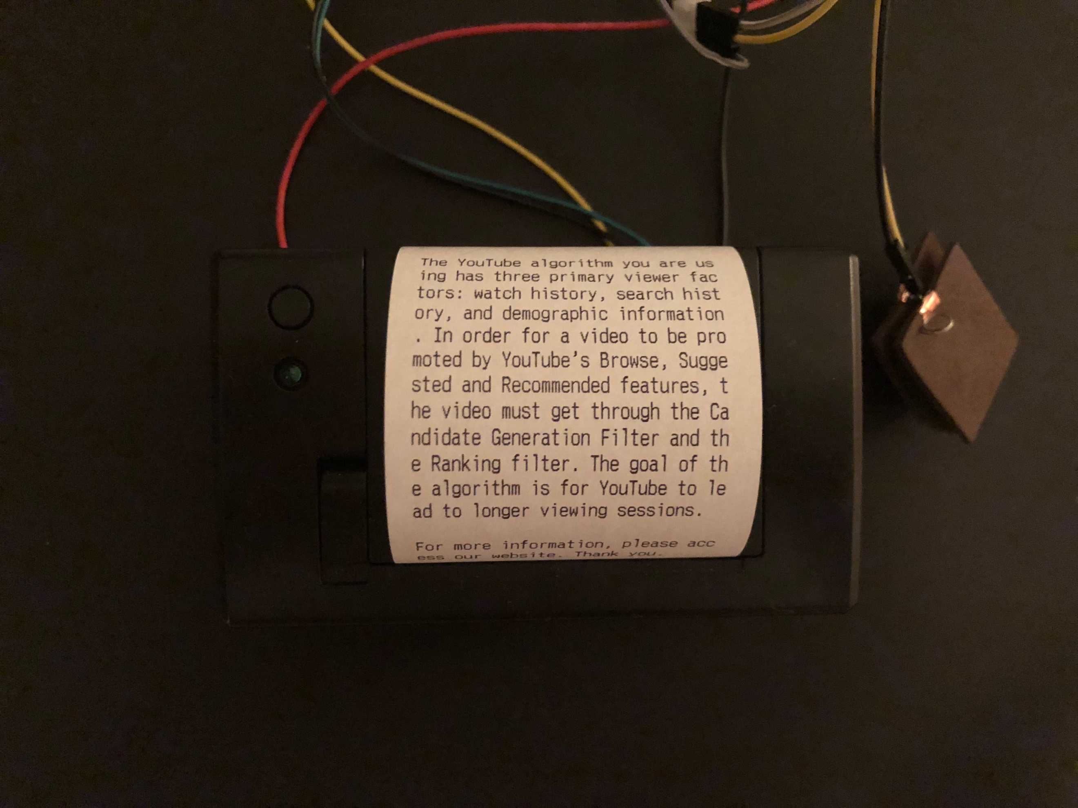

Figure 1. Photo of the first prototype

Based on the feedback collected from the first prototype, the message evolves into a form of receipt and presents the list of services, the data being used, and the list of technologies in the YouTube system in the second prototype. The mechanics of requesting for this receipt is the same as the first one.

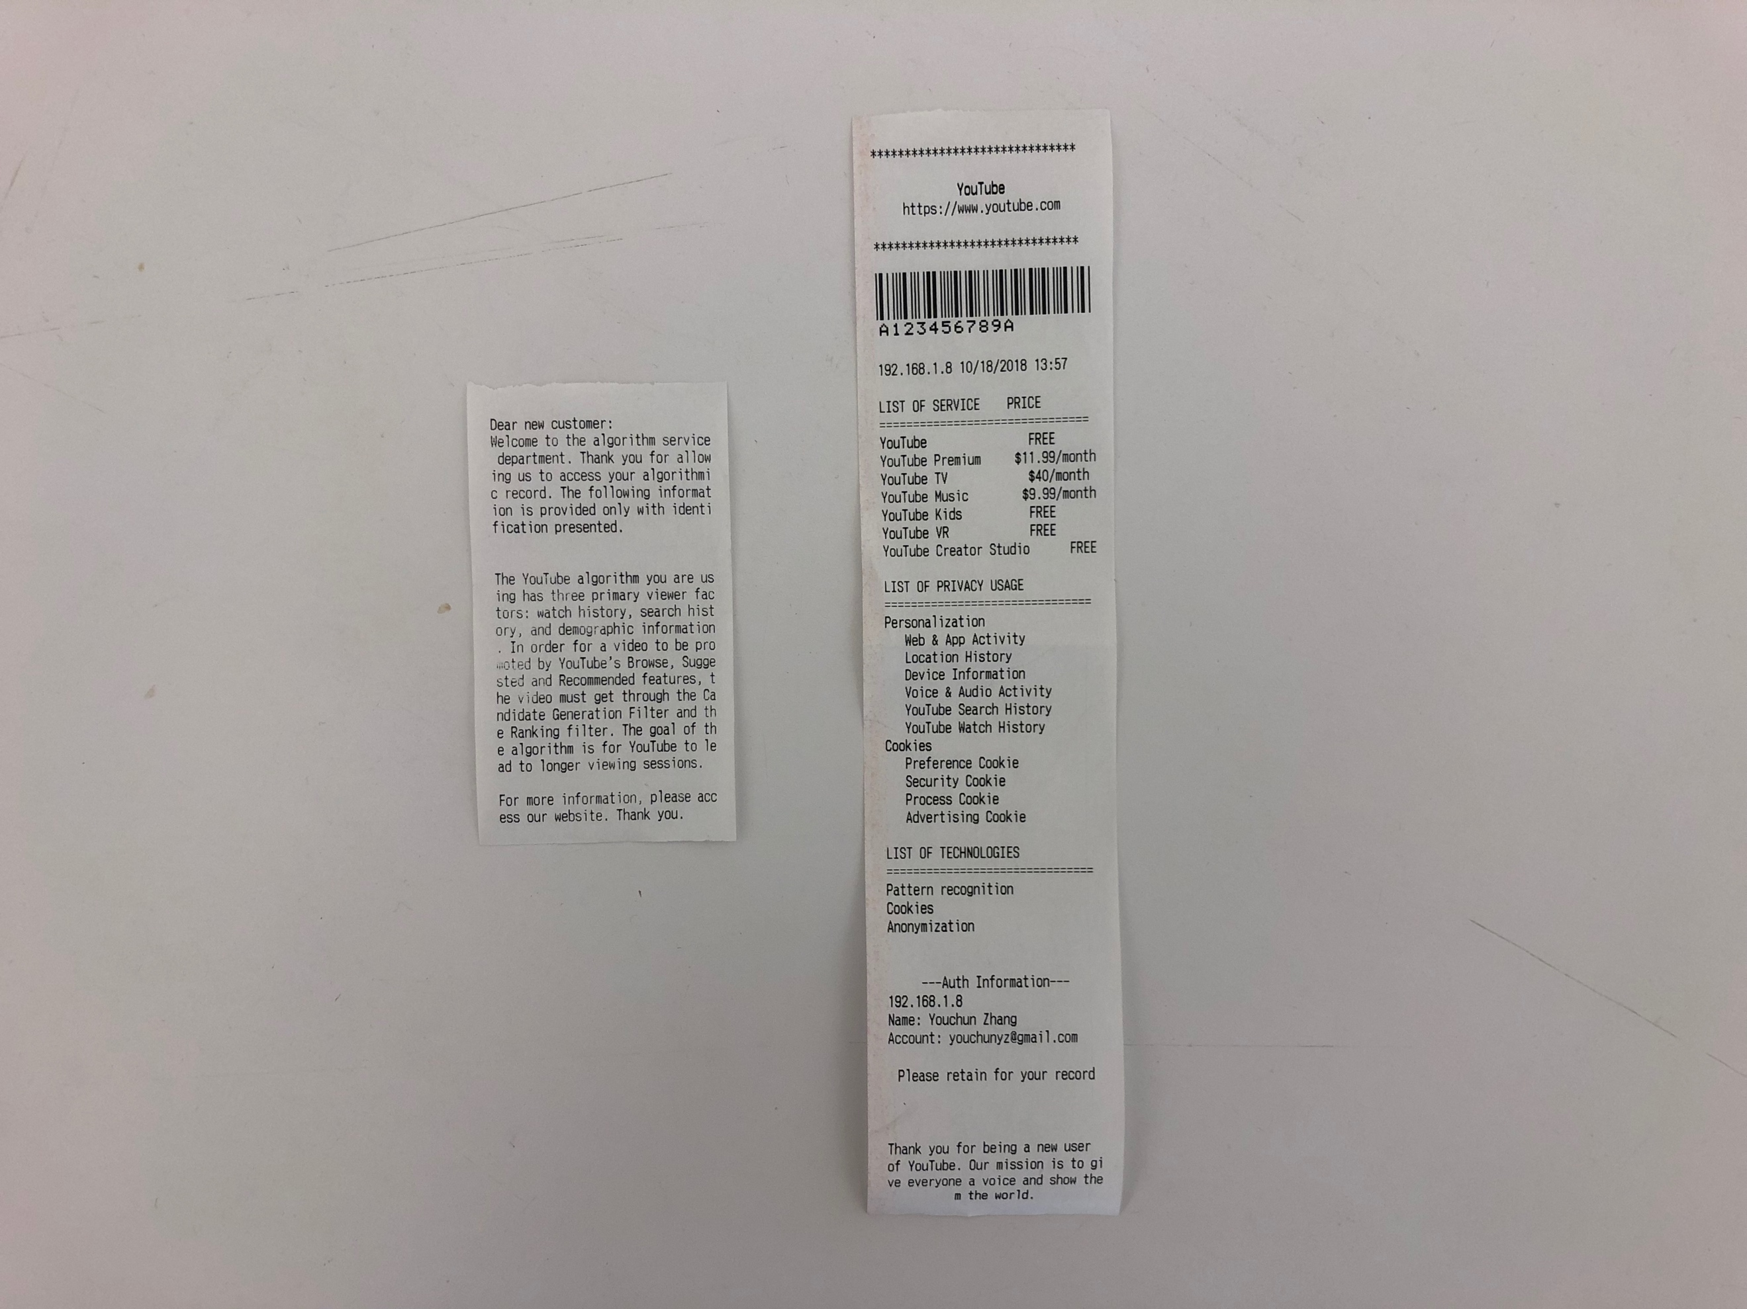

Figure 2. Photo of the printed receipts in the first and the second prototype

In the third prototype, more formats are being tested, including one trying to explain the details of search history, one elaborating the details of ad profiling of a real Google account and Google's estimation of its interests, and the other one with steps to code a simple recommended system using IMDB Top 250 movies dataset.

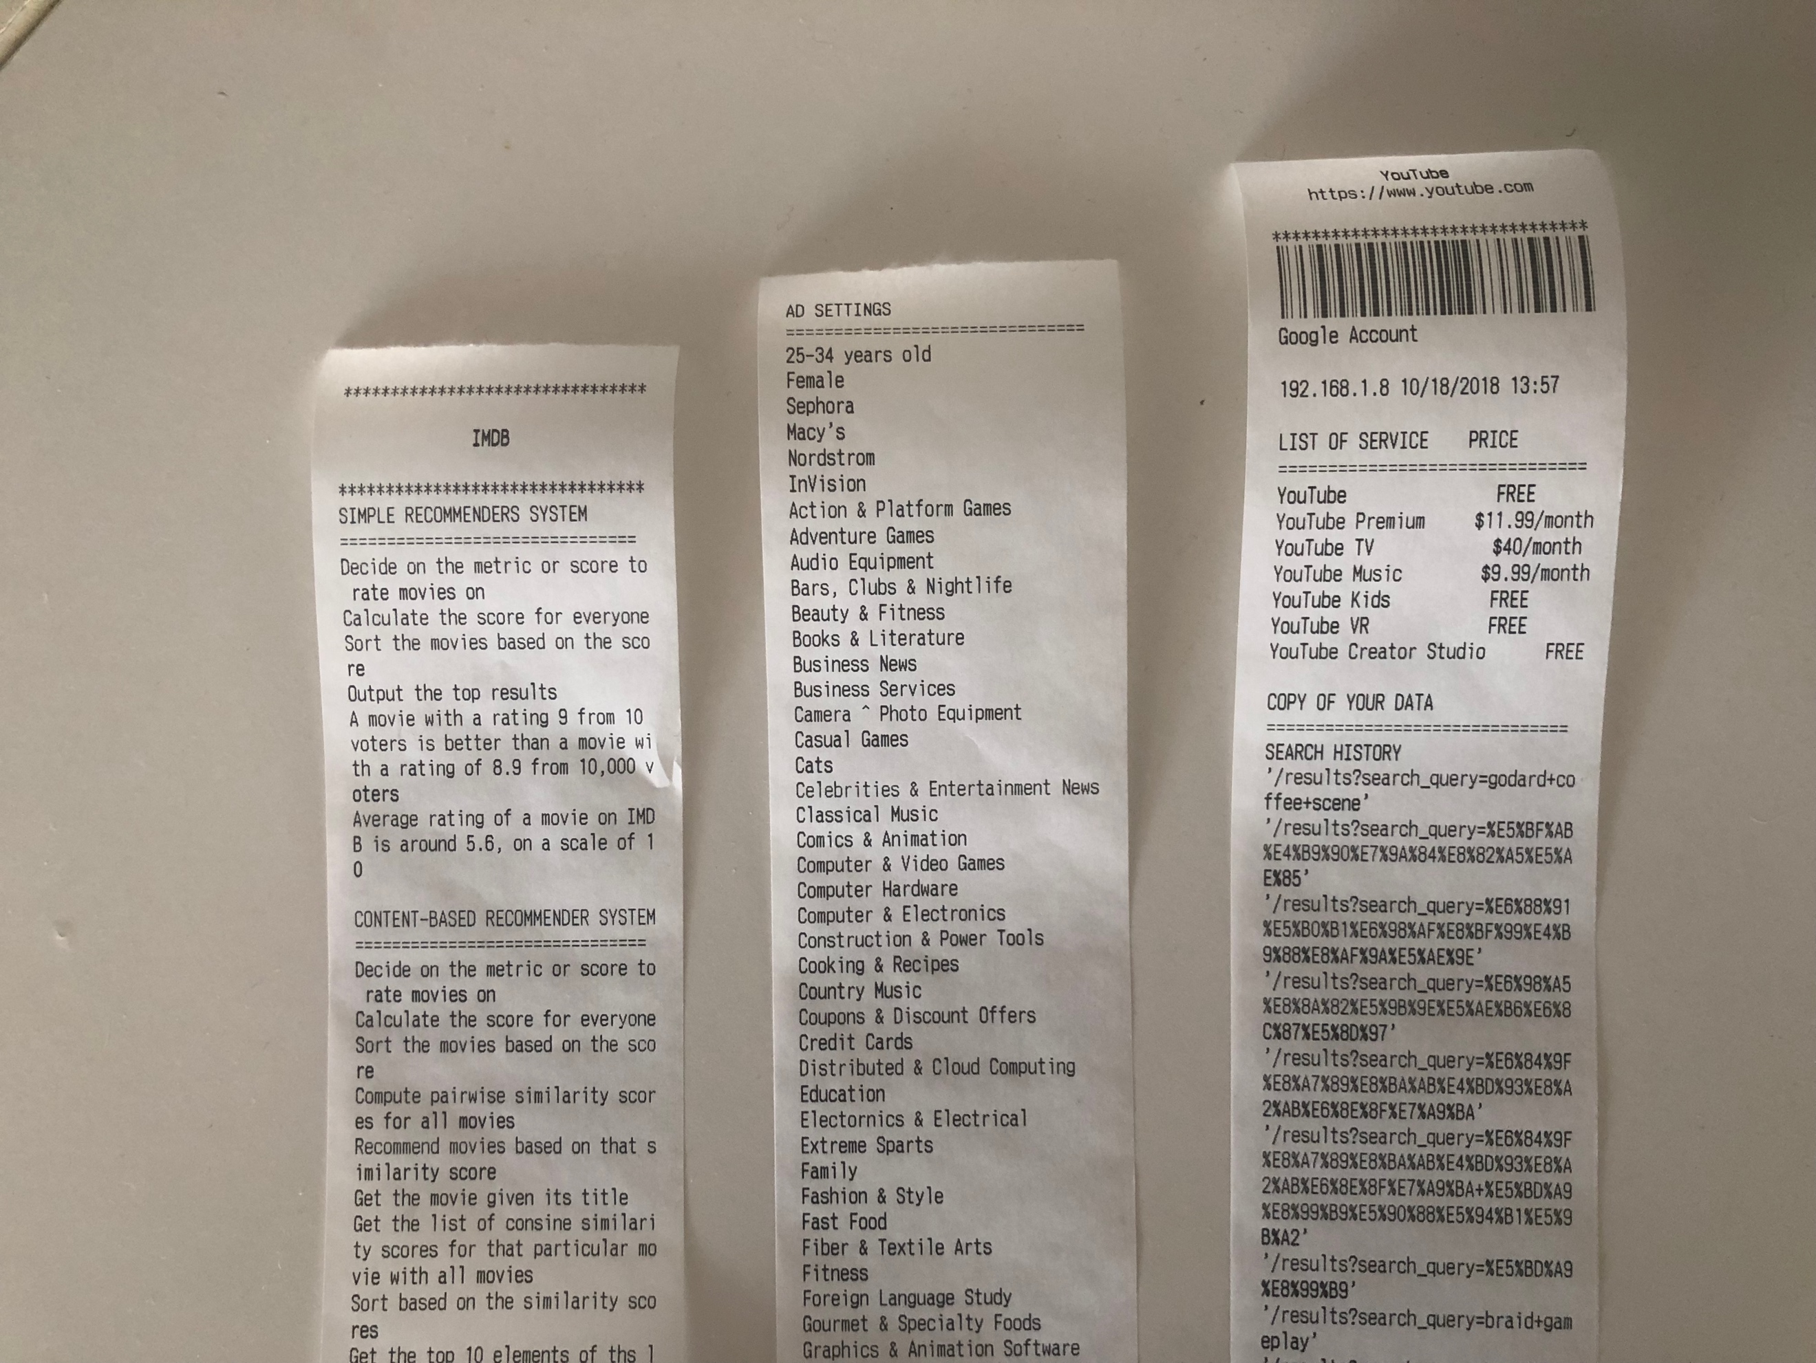

Figure 3. Photo of the printed receipts in the third prototype

In addition, two possible forms of physical setup are discussed at this stage. Depending on its intention, the experience of this receipt machine can be either private and personal or social and public. Imagine that the machine is a small portable device that the audience can purchase and bring it everywhere. Whenever he/she needs the information, he/she can connect it with an IoT device like a laptop. In the other scenario, the audience may be watching the machine work in a group. A story is told by the information printed by the multiple machines together.

*Prototypes: Reflection*

A 10-minute user interview and testing session is frequently being used to collect the feedback for each of the prototypes. The session is started with asking the user their regular usage of YouTube to get a basic idea of how familiar they are with the system and some of the features mentioned in the prototype. Then the user will need to respond to questions like what the prototype makes he/she think of, and what information he/she consider is the most important.

There are three processes involved in these prototypes - the process of the audience using the YouTube as a context, the process of the device printing the algorithmic information, and the process of the audience understanding the information. Therefore, the layer of information becomes a key concern of the prototypes. The information can be overwhelming if not designed properly.

Receipt as a physical proof of transaction is proved to be effective. Some audience expressed that the machine provided a funny tone. Also positioning itself outside of the digital world makes it both connected and disconnected.

*Prototypes: Design Value*

Works Cited

1. <https://www-statista-com.libproxy.newschool.edu/topics/2019/youtube/>
2. <https://www-statista-com.libproxy.newschool.edu/statistics/805656/number-youtube-viewers-worldwide/>
3. https://www-statista-com.libproxy.newschool.edu/statistics/259477/hours-of-video-uploaded-to-youtube-every-minute/